Research Design & Methods
In partial fulfilment of the requirements for the degree
Master of Science, Belmont University, Nashville TN

Paper title
Author
M.S. Audio Engineering Program, Curb College
ABSTRACT
Enter your abstract here, following the IMRaD principle. Your abstract should be 200 – 250 words (maximum 250 words). Do not forget to add your name and the title of your paper in the left and right corner of the page header starting on page 2 below. The final paper layout is a one-sided, two-column format with the font size of 10pt and typeface Times or Times New Roman. The running header and footer appear on all pages except the first.

Introduction
Provide an introduction of your research topic in this section. “Dr. Ko gave me the topic of XYZ” is not a valid introduction. The introduction should include purpose of your study, hypotheses, research question, and significance of your research.

Prior Art
This section should clearly establish the focus and purpose of the literature review. Provide the history of the research on your topic, along with some important developments discussed in seminal papers. Are there agreements or disagreements in the field? What are the latest trends in the particular line of research? Identify and describe any gaps that you find in the field. Make sure to weave the papers you reviewed into the text in the appropriate contexts.

Methods
Discuss your experimental design, including specific instrumentation, procedures, and subjects.

Good grammar should be used and writing should be easy to understand. Superlatives should be omitted. Words and phrases shall not be abbreviated in titles, abstracts, nor the first time they appear in the text. Metric units according to the System of International Units (SI) should be used.

Results
Summarize the expected results of your experiment. What kind of data do you expect to obtain? How will you analyze them? What could be your best- and worst-case results?

Figures, tables, diagrams, and charts must be scaled to fit the column. Make sure that the meaning is not lost when your paper is printed on a B&W printer. Photographs and graphic images should be saved as high-resolution (150 dpi) files and embedded in the text.

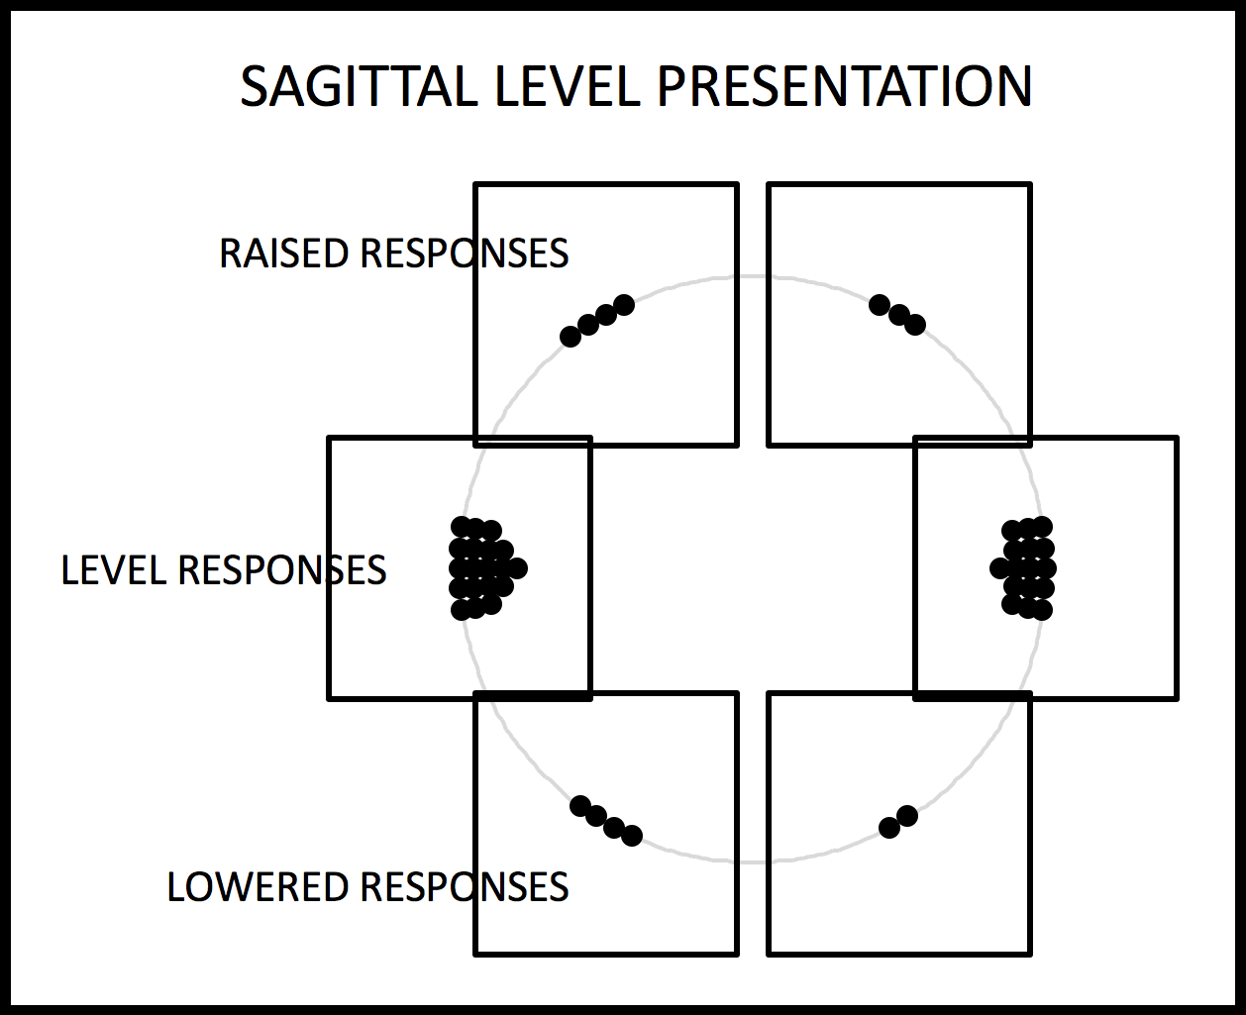
Figure 1. Subject response for the sagittal level presentation following inducement of the treatment.
Figures, tables, and illustrations should be placed consecutively in the text, as close as possible to their reference in the text. Figures must be normally oriented on the page and not turned sideways. All drawings and figures must be numbered (Fig. 1 etc.) and captioned.

Figure and table labels must be legible, at least 7-point size, using Helvetica font for preference. Filled areas should use screens of dots or cross-hatching rather than grey fills.

Below is an example of a table included in the section. Tables should be placed so as to not break across the page or column.

 | Tercel | Civic | Escort | MX-3
Toyota | 1.00 | 0.83 | 0.87 | 0.48
Honda | 0.83 | 1.00 | 0.73 | 0.18
Ford | 0.87 | 0.73 | 1.00 | 0.16
Mazda | 0.48 | 0.18 | 0.16 | 1.00
Table 1. Ratings of the sound “quality” of cars.

Discussion
Discuss the “big-picture” lessons you obtained from the literature you read. Relate possible outcomes of your project to this “big-picture” lessons, especially to the gaps in the literature that you identified in the Prior Art section. How can your project help address the unsolved problem(s) in the field?

Equations should be placed on separate lines and numbered. Also make sure that equations are readable in a printout.

 (1)
Where  is the calculated quantum interval
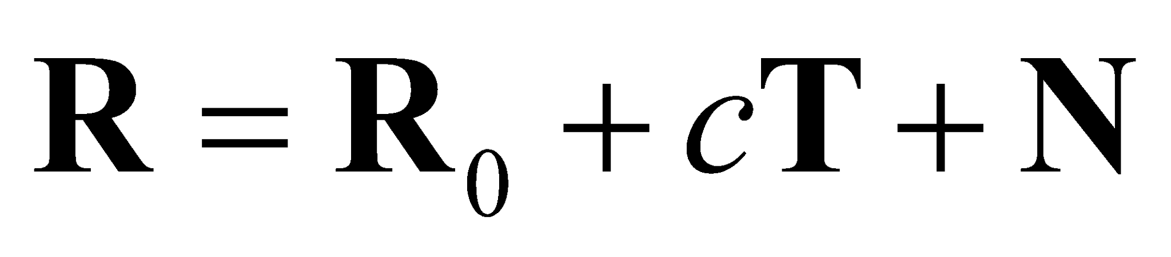 (2)
It can be shown that
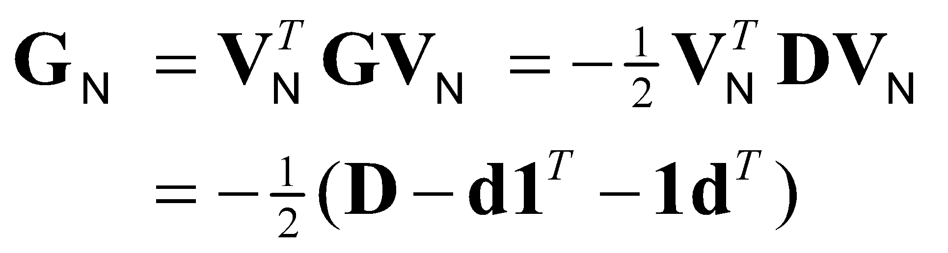 (3)
where
 (4)
Applying theorem 3 to 1, the theory of phase transitions with differential nonlinearity can be expressed using Equation 5.
 (5)

Conclusions
Summarize the most important point(s) of your project.

Papers for AES conventions are not edited by the AES editorial staff. Papers will be published exactly as submitted. It is therefore important that authors prepare their manuscripts in accordance with published guidelines.

Further Research
Provide any ideas of future works.

It is a good idea to PDF and print your file before submission. Are the figures easy to read? Did any of the figures or text move from where it was supposed to be? Are the page breaks in the correct places? If not, you may have to adjust your PDF rendering settings.

References
- Citation 1
- Citation 2
- Citation 3
- Citation 4
- Citation 5
- Citation 6
- Citation 7
- Citation 8
- and so on…
References should be in the IEEE citation format (refer to “IEEE Citation Guidelines.pdf”).

